The heat is on to save energy
ACE Energy August 2022
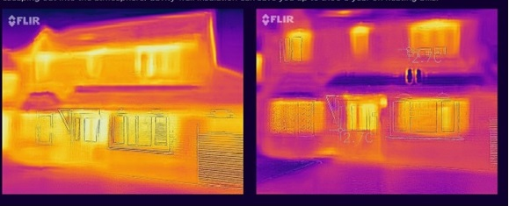
BEFORE AND AFTER: Photo of the outside of a house taken by the thermal imaging camera showing before and after the fitting of cavity wall insulation.

The ACE Energy Group has bought a thermal imaging camera to help homeowners and businesses identify where heat is being lost around the house or office.
The project to use the camera with be launched in the early autumn this year so that residents can become better informed on how to insulate their homes.
Demonstrations of how the camera works will be given at the Green Day event on 25 September 2022. A number of volunteers will be trained to use the camera and will carry out a thermal imaging survey of a resident’s home on request. A summary of the findings will then be sent directly to the resident.
The aim is to increase awareness of energy conservation at a time of escalating price increases.
The group is keen to provide advice on a range of energy topics including information on Government support and grants as well as matters such as green mortgages and loans, and is establishing close links with schools and the community drawing attention to several local networks already in existence.
The group has established six projects and will present these during Green Day, organised by the Town Council to ne held in the Market Place and Town Hall.
The projects include:
- Climate related legislation and grants - available for the introduction of heat pumps and other energy changes.
- Car sharing to include information on Lift-Share which is a scheme already in existence in Norfolk but could be further publicised.
- Use of local food produce and distribution to reduce energy costs and the need for transportation.
- Energy saving solutions suitable for individuals and households – these can be simple and effective.
We look forward to seeing you there and answering your questions.

